TOGAF® Standard – Architecture Deliverables Phase B
Version 1.0
October 2026
Barangay San Antonio Health Department Enterprise Architecture
Barangay San Antonio Health Center, Pasig City
Document Version History
Version  Number | Version  Date | Revised By | Description | Filename
1.0 | October 22, 2026 | UA&P Solution Architecture team | First issue, based on interviews (October 2–21, 2026) and verification answers (October 22, 2026) | B1 - Architecture Deliverables (Phase B).docx

Contents
1. Architectural Artifacts 5
2. Phase B: Business Architecture Artifacts 8
2.1 Business Capability Map 8
2.2 Organization/Actor Catalog 9
2.3 Role Catalog 9
2.4 Driver/Goal/Objective Catalog 10
2.5 Actor/Role Matrix 10
2.6 Business Service/Function Catalog 11
2.7 Location Catalog 11
2.8 Process Flow Diagrams 12
2.9 Process/Event/Control/Product Catalog 14
2.9.1 BP-2 Maintenance medicine pickup 14
2.9.2 BP-4 Referral 15
2.9.3 BP-6 Operation Timbang Plus 15
2.9.4 BP-7 Dental visit 15
2.9.5 BP-8 Budget and emergency purchase 16
2.9.6 BP-9 Infectious waste disposal 16
2.10 Business Event Catalog 16
2.11 Business Gap Analysis 17
A Abbreviations 18
Tracking Information
Project Name | Barangay San Antonio Health Department Enterprise Architecture
Prepared By | Rome Victor Mag-iba Sendin (Group Leader); Samuel Anthonius Badillo; Wilson Halim; Kevin Enrico Ang | Document Version No. | 1.0
Title | Architecture Deliverables – Phase B: Business Architecture | Document Version Date | October 22, 2026
Reviewed By | Dr. Glynnis Lynn U. Bonilla, Medical Officer IV (Executive Sponsor) | Review Date | October 23, 2026
Distribution List
From | Date | Phone/Email
Rome Victor Mag-iba Sendin, Group Leader, UA&P Solution Architecture | October 22, 2026 | romevictor.sendin@uap.asia / 09456315746

To | Action* | Due Date | Phone//Email
Dr. Glynnis Lynn U. Bonilla, Medical Officer IV | Approve | October 23, 2026 | bsahealthcenter@gmail.com
Hon. Thomas Raymond U. Lising, Punong Barangay | Review | October 23, 2026 | bsahealthcenter@gmail.com
Hon. Rachel Marie S. Rustia-Olarte, Co-Chair, Committee on Health & Nutrition | Review | October 23, 2026 | bsahealthcenter@gmail.com
Mr. Joel Pira, Instructor, Solution Architecture (UA&P) | Review | October 23, 2026 | joel.pira@uap.asia
* Action Types: Approve, Review, Inform, File, Action Required, Attend Meeting, Other (please specify)

Architectural Artifacts
While the Enterprise Metamodel is used to support the structuring of architectural information, most stakeholders do not need or wish to know the detail contained within the Architecture Content Framework in this manner. Therefore, the use of catalogs, matrices, and diagrams is introduced to facilitate the presentation of architectural information so that it may be used for reference and governance purposes more readily.
Catalogs are lists of building blocks of a specific type or related types, matrices are grids that show relationships between two or more entities, and diagrams are graphical renderings of architectural content.
In summary, the result of an Architecture Development Method (ADM) developed architecture consists of a number of defined Architecture Building Blocks populated into architecture catalogs, with relationships specified between those building blocks in architecture matrices, and/or also presented as diagrams, as appropriate to satisfy the stakeholder concerns.
The TOGAF® Standard provides a set of recommended artifacts, summarized as follows:
ADM Phase | Artifact
Preliminary Phase | Principles catalog
Phase A | Stakeholder Map matrix  Value Chain diagram  Solution Concept diagram  Business Model diagram  Business Capability map  Value Stream map
Phase B | Organization/Actor catalog  Driver/Goal/Objective catalog  Role catalog  Business Service/Function catalog  Location catalog  Process/Event/Control/Product catalog  Contract/Measure catalog  Business Capabilities catalog  Value Stream catalog  Value Stream Stages catalog  Business Interaction matrix  Actor/Role matrix  Value Stream/Capability matrix  Strategy/Capability matrix  Capability/Organization matrix  Business Footprint diagram  Business Service/Information diagram  Functional Decomposition diagram  Product Lifecycle diagram  Goal/Objective/Service diagram  Business Use-Case diagram  Organization Decomposition diagram  Process Flow diagram  Event diagram  Business Capability map (updated)  Value Stream map (updated)  Organization map
Phase C: Data Architecture | Data Entity/Data Component catalog  Data Entity/Business Function matrix  Application/Data matrix  Conceptual Data Diagram  Logical Data Diagram  Data Dissemination diagram  Data Security diagram  Data Migration diagram  Data Lifecycle diagram
Phase C: Application Architecture | Application Portfolio catalog  Interface catalog  Application/Organization matrix  Role/Application matrix  Application/Function matrix  Application Interaction matrix  Application Communication diagram  Application and User Location diagram  Application Use-Case diagram  Enterprise Manageability diagram  Process/Application Realization diagram  Software Engineering diagram  Application Migration diagram  Software Distribution diagram
Phase D | Technology Standards catalog  Technology Portfolio catalog  Application/Technology matrix  Environments and Locations diagram  Platform Decomposition diagram  Processing diagram  Networked Computing/Hardware diagram  Network and Communications diagram
Phase E | Project Context diagram  Benefits diagram
Requirements Management | Requirements catalog

Phase B: Business Architecture Artifacts
This section presents the Phase B artifacts committed in the Tailored Architecture Framework for the Barangay San Antonio Health Department, based on 16 interviews (October 2–21, 2026) and the health center's verification answers (October 22, 2026).
Tailoring note: the two Phase B templates (Architecture Requirements Specification and Architecture Roadmap) have no sections for business catalogs, matrices and diagrams. The Architecture Deliverables template, whose artifact table includes a Phase B row (Section 1), is therefore used to present them.

Business Capability Map
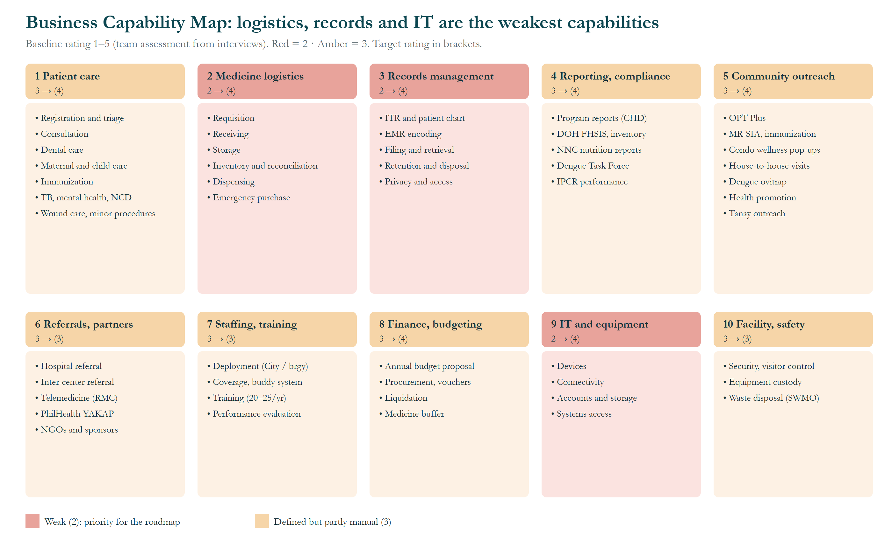
Figure 1. Business Capability Map (baseline → target ratings).
How to read it: each of the ten boxes is a level-1 capability; the bullets inside are the abilities it contains. The rating shows baseline → (target) on a 1–5 scale, assessed by the team from the interviews. Red = 2 (weak), amber = 3 (defined but partly manual).
- Weakest (2 → 4): medicine logistics (no stock alerts, partial deliveries), records management (~8,000 mixed charts, misfiling) and IT and equipment (10-year-old laptops, no frontline computers, personal accounts).
- Working but manual (3 → 4): patient care, reporting and compliance, community outreach, finance and budgeting.
- No change planned (3 → 3): referrals, staffing and training, facility and safety; these work adequately or are controlled by the City.
- Takeaway: the ratings set the roadmap priority: WP1 for logistics, WP4 for records, WP2, WP3 and WP7 for IT.

Organization/Actor Catalog
Organization unit | Type | Actors | Relationship to health center
Office of the City Mayor | External (City) | Mayor Victor Ma. Regis N. Sotto | Approves major system and policy changes
Pasig City Health Department | External (City) | City Health Officer Dr. Joseph R. Panaligan; CAO Dr. Philip Patrick C. Co; Records Officer Rosa C. Santos; Secretary Officer Algernon A. Victorino; program coordinators; city dental supervisor | Mandates, City staff, medicine supply, systems, report review
Barangay Council | Internal (Barangay) | Punong Barangay Thomas Raymond U. Lising; Kagawad Rachel Marie S. Rustia-Olarte (Co-Chair, Committee on Health & Nutrition) | Funding, approvals, programs
Barangay Treasurer's Office | Internal (Barangay) | Treasurer Rosalin S. Labayan; bookkeeper | Budget execution and liquidation
Barangay Nutrition Committee | Internal (Barangay) | Nutritionist (vice-chair), BNS, Kapitan, Kagawad | PPAN-aligned nutrition plans
Barangay IT team | Internal (Barangay) | IT staff (barangay hall) | Checks barangay equipment every 3 months
Health center | Core | 16 on-site staff (see Role Catalog) | Care delivery
National agencies | External | DOH; National Nutrition Council; PhilHealth | Programs, standards, YAKAP, FHSIS
Care partners | External | Rizal Medical Center (incl. telemedicine); Pasig City General Hospital; Oranbo and Kapitolyo Health Centers; YAKAP pharmacy (Estancia) | Referrals and medicines
Community | External | Residents; ~63 condominiums; 5 Ortigas private preschools; Dengue Task Force; Tanay relocatees | Service users and access gatekeepers
LGU Solid Waste Management Office | External (City) | Collection team | Collects infectious waste twice a month

Role Catalog
Role | No. | Employer / status | Name(s)
Medical Officer IV (Rural Health Physician) | 1 | City; permanent | Dr. Glynnis Lynn U. Bonilla
Rural Health Dentist | 1 | City; permanent (Tue–Thu here; Mon/Fri at Oranbo) | Dr. Joseph P. Magpali, DMD
Rural Health Nurse | 1 | City; permanent | Ms. Nita N. Hardman, RN
Rural Health Midwife | 1 | City; permanent | Ms. Mafe B. Abong, RM
Nutritionist-Dietitian (Nutrition Officer II) | 1 | City; permanent (Tue–Thu here) | Mr. Christian Jay G. Vasquez, RND
Barangay Nutrition Scholar | 1 | City; permanent since about 2021 | Ms. Mary Anne M. Verches
IT Officer / Medical Encoder | 1 | City; permanent | Mr. Tito F. Reyes
Pasig Health Aide | 4 | City; job order (paid and hired by CHD) | Ms. Janneth D. Correa (OIC), Ms. Rowena A. Intalan, Ms. Rosemarie T. Labandero, Ms. Procelyn L. Tatoy
Barangay Health Worker | 3 | Barangay; contractual (paid and hired by the barangay) | Ms. Joan Marie E. Barcenas, Mr. Perfecto S. Pestaño Jr., Ms. Josefina G. Roa (equipment custodian)
Security Officer | 1 | Barangay | Mr. Jeson C. Medez
Utility | 1 | Barangay | Ms. Vilma D. Lendio

Driver/Goal/Objective Catalog
Driver | Goal | Objective (proposed)
Prescriptions retyped in EMR and YAKAP (Dr. Bonilla, Dr. Magpali) | G1 Enter data once | Prescription entries 3 → 1
Three-month medicine shortage; ~₱150,000 barangay spend (verification) | G2 Keep medicines in stock | Stock-out months → 0
Misfiled charts; after-hours reporting (Ms. Abong, Nurse Hardman) | G3 Faster records and reports | Retrieval < 1 minute; no after-hours compilation
Work data on personal accounts (Mr. Vasquez, Nurse Hardman) | G4 Official, secure work tools | No work files on personal accounts
Queue complaints; condo resistance (Dr. Bonilla, Ms. Verches) | G5 Better patient flow and reach | Fewer complaints; higher condo coverage

Actor/Role Matrix
R = Responsible (does it) · A = Accountable · S = Supports · C = Consulted.
Activity | Doctor | Nurse | Midwife | Dentist | Nutri. | BNS | Encoder | Aides/ BHWs | Kap/ Kag | CHD
Registration and vitals |  | A | S |  |  |  |  | R
Consultation and diagnosis | R/A | S | S
Dental care |  |  |  | R/A
EMR encoding | R |  | S | R |  |  | R |  |  | A
Dispensing |  | R/A |  |  |  |  |  | S
Medicine requisition and inventory |  | R/A |  |  |  |  |  | S |  | S
Emergency medicine purchase | C | C |  |  |  |  |  |  | R/A
Monthly program reports | A | R | R | R | R | S | S | S |  | C
OPT Plus |  |  | S |  | A | R |  | S | S
MR-SIA / immunization |  | R/A | R |  |  |  |  | S |  | C
Condo wellness pop-up | R | S | S |  |  |  |  | S | A
Dengue ovitrap |  | A |  |  |  |  |  | R |  | C
Referral and escort | A | R |  |  |  |  |  | S
Annual health budget | C |  |  |  | C |  |  |  | R/A
Process or system changes | R | C | C | C |  |  | C |  | C | A
Equipment custody |  | A |  |  |  |  |  | R (Roa)

Business Service/Function Catalog
Service | Schedule / volume | Function owner
Medical consultation | Mon/Tue/Fri 8–11 AM; 360 last month | Dr. Bonilla
Maintenance-medicine dispensing | Mon/Wed/Fri 1–4 PM; 297 pickups last month | Nurse Hardman
Immunization | Wednesdays; MR-SIA campaigns | Nurse Hardman; Ms. Abong
Prenatal and family planning | Consultation days; house-to-house visits | Ms. Abong
Dental | Tue–Thu, scheduled; 10–15 patients a day | Dr. Magpali
Nutrition (OPT Plus, counseling, feeding) | OPT Jan–Mar; 798 children 0–59 months | Mr. Vasquez; Ms. Verches
TB, mental health, smoking cessation, NCD | Ongoing program care | Nurse Hardman
Referral | About 30 a month | Dr. Bonilla; Nurse Hardman
Dengue ovitrap | Report every 2 weeks | Aides and BHWs
PhilHealth YAKAP registration and prescriptions | Per patient | Dr. Bonilla; Mr. Reyes

Location Catalog
Location | Use
Health center (Barangay San Antonio) | All clinic services, records room, medicine storage
Barangay hall | Barangay IT team; Treasurer; Council
Old Pasig City Hall | Hard-copy report submission
Condominiums (~63), 5 Ortigas private preschools, daycare, streets | Outreach, OPT Plus, MR-SIA, wellness pop-ups
Tanay, Rizal relocation site | Monthly OPT Plus visits, January–March
Rizal Medical Center, PCGH, Oranbo and Kapitolyo Health Centers | Referral destinations

Process Flow Diagrams
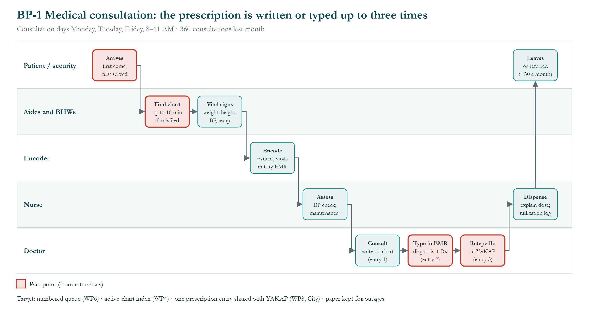
Figure 2. BP-1 Medical consultation.
How to read it: each row (“swimlane”) is one actor: patient/security, aides and BHWs, encoder, nurse and doctor. Boxes run left to right in time order; red boxes are pain points. Volume: 360 consultations last month (Monday, Tuesday and Friday, 8–11 AM).
  - The patient arrives and is served first come, first served.
  - An aide or BHW finds the chart (up to 10 minutes if misfiled) and takes vital signs.
  - The encoder enters the patient and vitals in the City EMR.
  - The nurse assesses (BP check; maintenance patient?).
  - The doctor consults and writes on the chart (entry 1), types the diagnosis and prescription in the EMR (entry 2), and retypes the prescription in PhilHealth YAKAP (entry 3).
  - The nurse dispenses and explains the dose, recording it in the utilization log; the patient leaves or is referred (about 30 referrals a month).
Takeaway: retyping a PhilHealth patient's 5–10 medicines is avoidable work. Targets: numbered queue (WP6), active-chart index (WP4), one shared prescription entry (WP8, City); paper stays as the outage fallback.
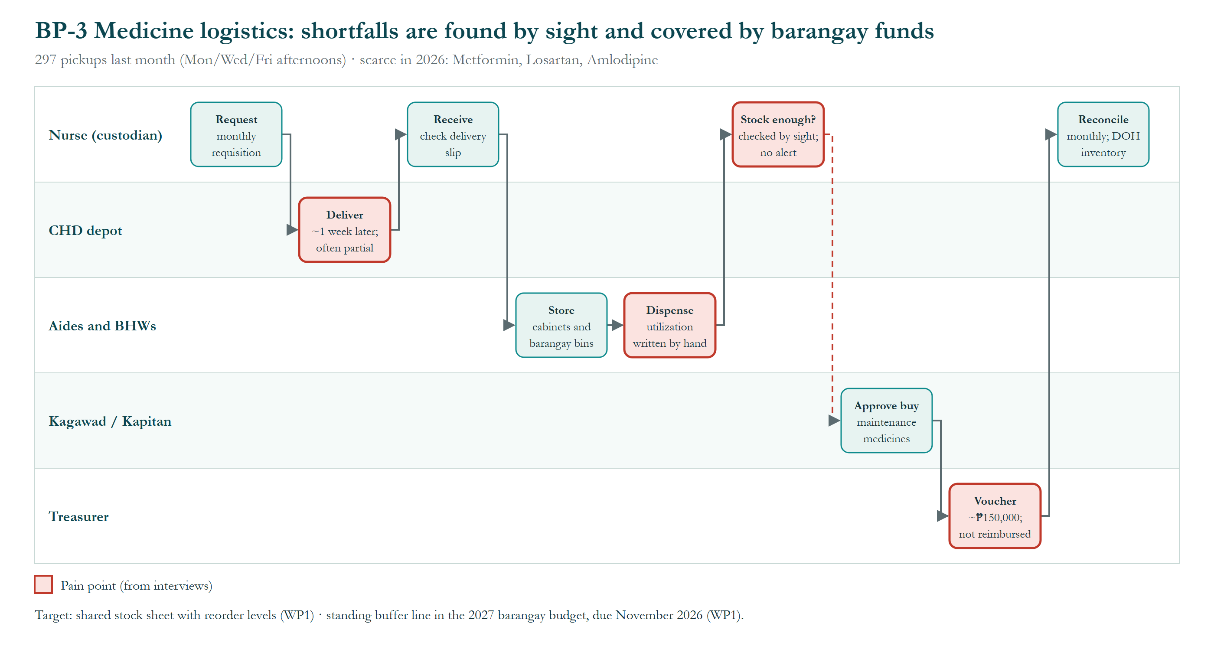
Figure 3. BP-3 Medicine logistics.
How to read it: rows are the nurse (medicine custodian), the City Health Department depot, aides and BHWs, the Kagawad/Kapitan and the Treasurer. Volume: 297 maintenance-medicine pickups last month.
  - The nurse sends a monthly requisition to the CHD.
  - The CHD delivers about a week later, often incomplete; the nurse checks the delivery slip and stores stock in cabinets and barangay bins.
  - Aides and BHWs dispense and write each issue in the utilization log by hand.
  - Whether stock is enough is checked by sight; there is no alert.
  - When short, the Kagawad and Kapitan approve a barangay purchase and the Treasurer issues a voucher (about ₱150,000 in 2026, not reimbursed).
  - The nurse reconciles stock monthly for the DOH inventory report.
Takeaway: shortages are found late and paid for unplanned. Targets: a shared stock sheet with reorder levels and a standing buffer line in the 2027 barangay budget (both WP1).
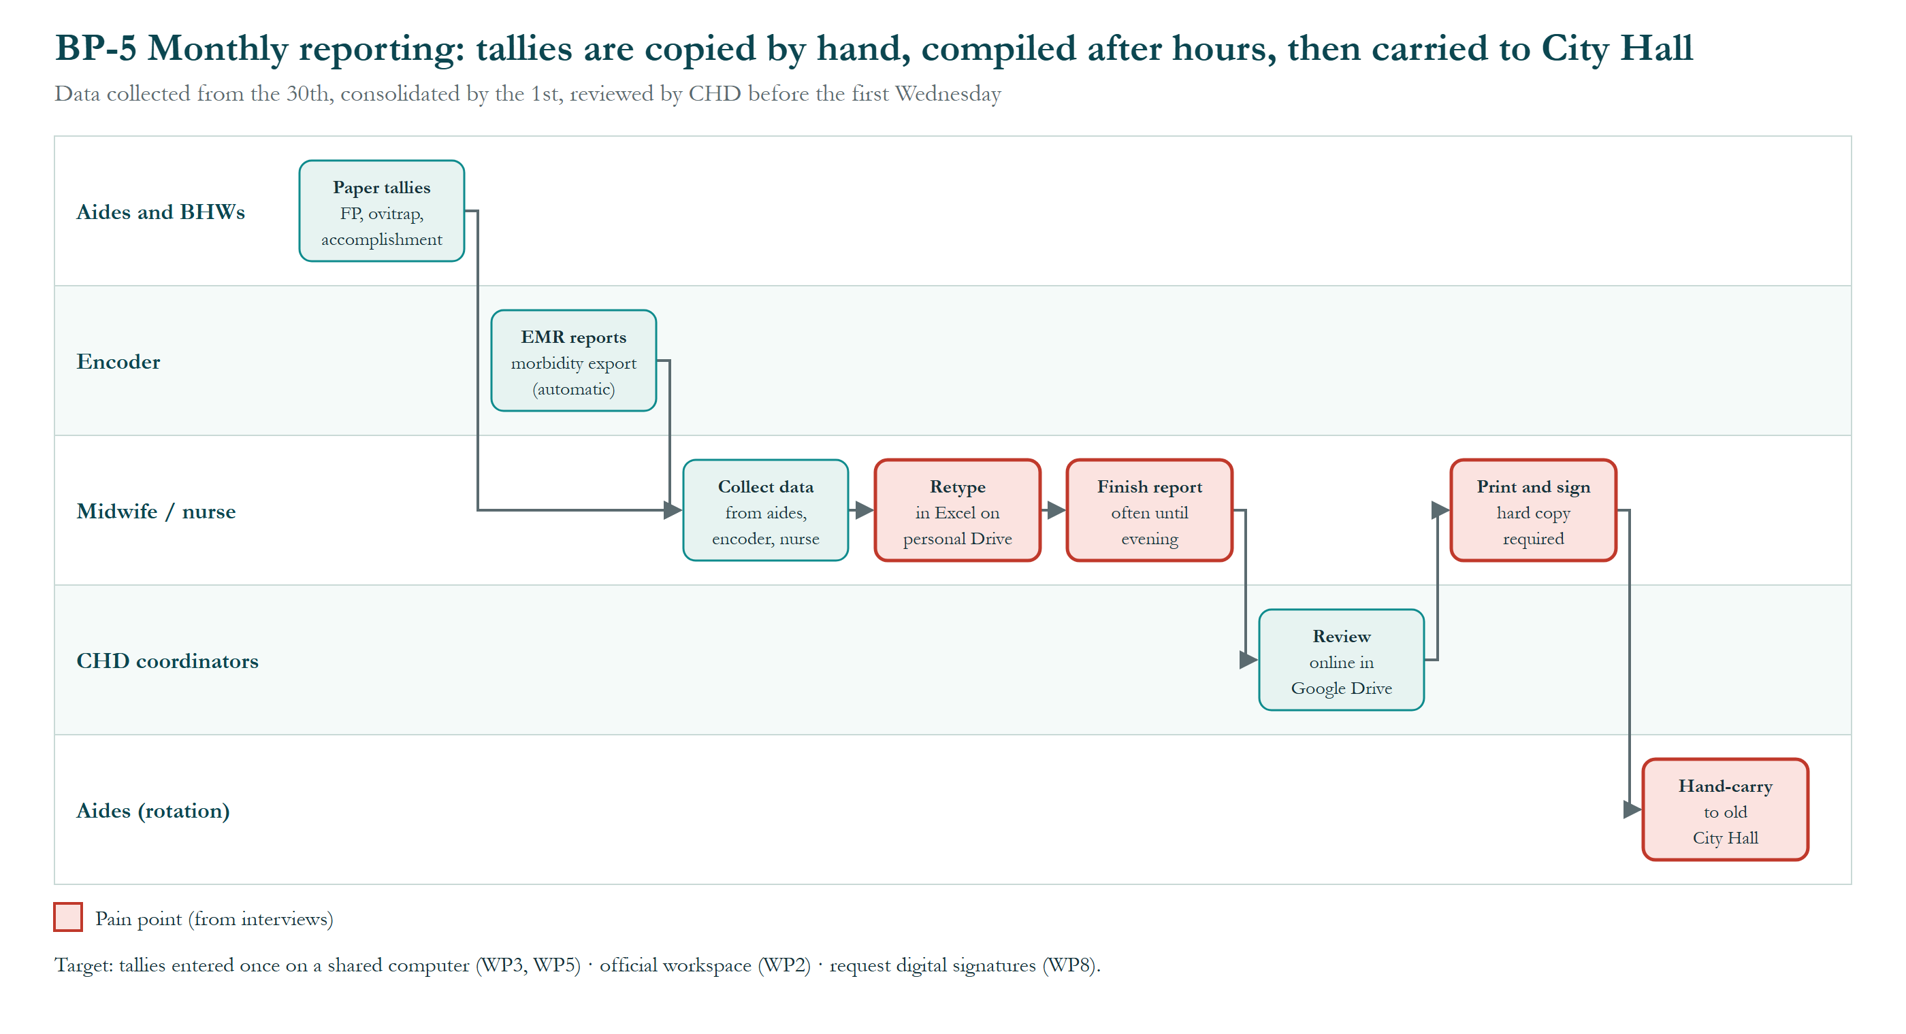
Figure 4. BP-5 Monthly reporting.
How to read it: rows are aides and BHWs, the encoder, the midwife/nurse, CHD coordinators and aides on rotation. Timing: data collected from the 30th, consolidated by the 1st, reviewed by the CHD before the first Wednesday.
  - Aides and BHWs keep paper tallies (family planning, ovitrap, accomplishment); the EMR produces the morbidity export automatically.
  - The midwife or nurse collects data from aides, the encoder and the nurse.
  - Figures are retyped into Excel on personal Google Drive and finished, often into the evening.
  - CHD coordinators review the report online in Google Drive.
  - A hard copy is printed and signed (required) and carried by aides on rotation to the old City Hall.
Takeaway: only the EMR export is automatic; reports are never late, but at the cost of after-hours work. Targets: shared computers and a single tally sheet (WP3, WP5), official workspace (WP2), and a request to accept digitally signed reports (WP8).

Process/Event/Control/Product Catalog

BP-2 Maintenance medicine pickup
Trigger: Monday, Wednesday or Friday, 1–4 PM.
# | Actor | Activity | Tool / record
1 | Aide/BHW | Checks patient booklet and enrollment | Booklet, ITR
2 | Aide/BHW | Takes BP; records in monthly monitoring | Maintenance monitoring sheet
3 | Aide/BHW, nurse | Dispenses one month's supply (10–20 pieces during shortages) | Utilization log
4 | Patient | Signs utilization record | Utilization log
5 | Encoder | Encodes dispensing | City EMR

Pain points: 297 pickups last month; supply often short; quantity limits.
Target change: Digital stock view with reorder levels; buffer stock.

BP-4 Referral
Trigger: Patient needs a laboratory, hospital care, or a doctor when the physician is absent.
# | Actor | Activity | Tool / record
1 | Doctor or nurse | Decides on referral; writes referral | Referral slip
2 | Aide/BHW | Brings patient record; escorts by barangay vehicle when needed | Patient chart
3 | Receiving facility | Rizal Medical Center, PCGH, Oranbo or Kapitolyo, or telemedicine | —

Pain points: About 30 a month; no referral log or outcome feedback.
Target change: Referral register with outcome follow-up.

BP-6 Operation Timbang Plus
Trigger: January–March; preparation year-round.
# | Actor | Activity | Tool / record
1 | Nutritionist | Plans schedule; letters signed by Dr. Bonilla, Kapitan and Dr. Panaligan | Letters
2 | BNS + aides/BHWs (3–5 per team) | Weigh and measure 0–59 months; vitamin A, deworming | e-OPT form, master list
3 | BNS | Visits Tanay monthly Jan–Mar; follow-ups for missed children | Master list
4 | BNS | Encodes results | NNC e-OPT tool, Google Sheets
5 | Nutritionist | Validates (at least 80% coverage); reports to city → region → national | Google Drive

Pain points: 798 children; condo access refused; Tanay distance; 2–3 GB files on 15 GB personal storage.
Target change: Field laptop for direct entry; official storage.

BP-7 Dental visit
Trigger: Scheduled appointment (walk-in for new patients).
# | Actor | Activity | Tool / record
1 | Patient | Books a 15–60 minute slot | Appointment list
2 | Dental assistant | Pulls record; takes BP and temperature | Dental record
3 | Dentist | Treats (preventive, ART, extraction) | Dental record
4 | Dentist / assistant | Encodes dental chart; files PhilHealth claim | Dental eMED + PhilHealth

Pain points: Separate dental system; low preventive uptake.
Target change: Online/QR booking (dentist's plan); integration request to CHD.

BP-8 Budget and emergency purchase
Trigger: Annual budget cycle (proposals due November 2026) or an urgent need.
# | Actor | Activity | Tool / record
1 | Health center | Requests via Kagawad Rustia or Kapitan | Request
2 | Barangay Council | Prepares budget; Kapitan approves; City Council adopts | Budget
3 | Treasurer | Posting, bidding, voucher, check, liquidation | Ledger; Landbank
4 | Nutritionist | Submits 3-year nutrition plan (2026: ₱450,301; 2027: ₱650,809) | PPAs

Pain points: Speed depends on amount; no standing medicine buffer.
Target change: Costed requests in the 2027 budget; buffer line.

BP-9 Infectious waste disposal
Trigger: Waste generated during care.
# | Actor | Activity | Tool / record
1 | Utility / staff | Segregate and store infectious and hazardous waste | —
2 | LGU Solid Waste Management Office | Collects twice a month | —

Pain points: None reported.
Target change: No change; documented as part of facility and safety.

Business Event Catalog
Event | When | Impact
Consultation days | Mon/Tue/Fri 8–11 AM | Peak workload
Immunization | Wednesdays | Nurse and midwife busy
Maintenance-medicine pickup | Mon/Wed/Fri 1–4 PM | Dispensing and encoding load
Ovitrap report | Every 2 weeks | Field and reporting
Family planning unmet-need report | 3rd week of the month | Reporting
Monthly reports | 30th → 1st; CHD review before the first Wednesday | After-hours compilation
OPT Plus / MR-SIA | January–March | Whole team in the field
Infectious waste pickup | Twice a month (LGU SWMO) | Waste stored until pickup
Barangay budget proposals | Due November 2026 | Funding window
BNS convention | October/November (~₱2,000, paid by the Kapitan) | BNS away
City equipment audit | About every 6 months | City-issued devices checked

Business Gap Analysis
ID | Baseline | Target | Gap | Controlled by
BG-1 | Prescription written on the chart, typed in the EMR, then retyped in PhilHealth YAKAP | Entered once | No EMR–YAKAP link | City / vendor
BG-2 | Medicine stock tracked by hand and checked by sight | Continuous stock view with reorder alerts | No tracking tool | Health center
BG-3 | Barangay buys medicine shortfalls ad hoc (about ₱150,000 in 2026, not reimbursed) | Planned buffer stock | No standing budget line | Barangay
BG-4 | About 8,000 charts, active and inactive mixed; misfiled charts take up to 10 minutes | Active-chart index; inactive archived | No filing standard or records clerk | Health center
BG-5 | Reports compiled after hours; signed hard copies hand-carried to City Hall | Single tally source; digital submission | Redundant forms; hard-copy rule | Health center / City
BG-6 | First come, first served; complaints about order | Numbered queue | No queue process | Health center (CHO approval)
BG-7 | Aides and BHWs record on paper only (tech literacy about 2/5) | Shared computers and basic training | No devices; low skills | Barangay
BG-8 | Condo residents resist government services; letters often refused | Higher reach via partnerships | Access and trust | Barangay
BG-9 | Nurse and doctor carry heavy paperwork; one encoder for all systems | Encoding support | Encoder capacity | City / Barangay

- Abbreviations
Abbreviations, acronyms and reference codes used in this document and its figures, in alphabetical order.
Abbreviation | Meaning
ADM | Architecture Development Method, the step-by-step method of the TOGAF Standard
ART | Atraumatic Restorative Treatment (a dental filling technique)
BG-1 … | Business gap reference number (Phase B)
BHW | Barangay Health Worker
BNS | Barangay Nutrition Scholar
BP | Blood pressure
BP-1 … | Business process reference number
Brgy | Barangay
CAO | Chief Administrative Officer
CHD | City Health Department (Pasig City)
CHO | City Health Officer
DMD | Doctor of Dental Medicine
DOH | Department of Health
e-OPT | Electronic Operation Timbang Plus tool of the National Nutrition Council
eMed / eMED | Name of the City's electronic medical record system; “dental eMED” is its separate dental system
EMR | Electronic Medical Record
FHSIS | Field Health Services Information System (DOH)
FP | Family planning
G1 … G5 | Goal reference number
GB | Gigabyte (a unit of file size)
Hon. | Honorable (title of elected officials)
IPCR | Individual Performance Commitment and Review
IT | Information technology
ITR | Individual Treatment Record (the patient's registration form)
Kap / Kag | Kapitan (Punong Barangay) / Kagawad (barangay council member)
LGU | Local Government Unit
MR-SIA | Measles-Rubella Supplemental Immunization Activity
NCD | Non-communicable disease (e.g., hypertension, diabetes)
NGO | Non-government organization
NNC | National Nutrition Council
Nutri. | Nutritionist-Dietitian (table heading)
OIC | Officer-in-Charge
OPT / OPT Plus | Operation Timbang Plus: yearly weighing and measuring of children aged 0–59 months
PCGH | Pasig City General Hospital
PhilHealth | Philippine Health Insurance Corporation
PPAN | Philippine Plan of Action for Nutrition
PPAs | Programs, projects and activities
QR | Quick Response (a scannable square barcode)
RM | Registered Midwife
RMC | Rizal Medical Center
RN | Registered Nurse
RND | Registered Nutritionist-Dietitian
Rx | Prescription
SWMO | Solid Waste Management Office (City of Pasig)
TB | Tuberculosis
TOGAF | The Open Group Architecture Framework (the TOGAF® Standard)
UA&P | University of Asia and the Pacific
WP1 … WP9 | Work package (a group of related changes delivered together)
YAKAP | PhilHealth Yaman ng Kalusugan Program (primary-care benefit)

